**AIP EXPERIMENT 1.3**

**Student Name: Anmol Singh UID: 21MCA2820**

**Branch: MCA Section/Group : 6A**

**Semester: 2nd Date of Performance: 21-02-2022**

**Subject Name: AIP LAB Subject Code: 21CAP-655**

1. **Aim/Overview of the practical:**

**To implement basic concepts of Hashset&Arraylist.**

1. **Task to be done:**

**Q1) Write a Java program to create a new array list, add some colors (string) and print out the collection.**

**Q2) Write a Java program to append the specified element to the end of a hash set.**

**Q3) Write a Java program to iterate through all elements in a hash list.**

**Q4) Write a Java program to get the number of elements in a hash set.**

1. **Steps/Commands involved to perform practical:**

**Q1 Write a Java program to create a new array list, add some colors (string) and print out the collection.**

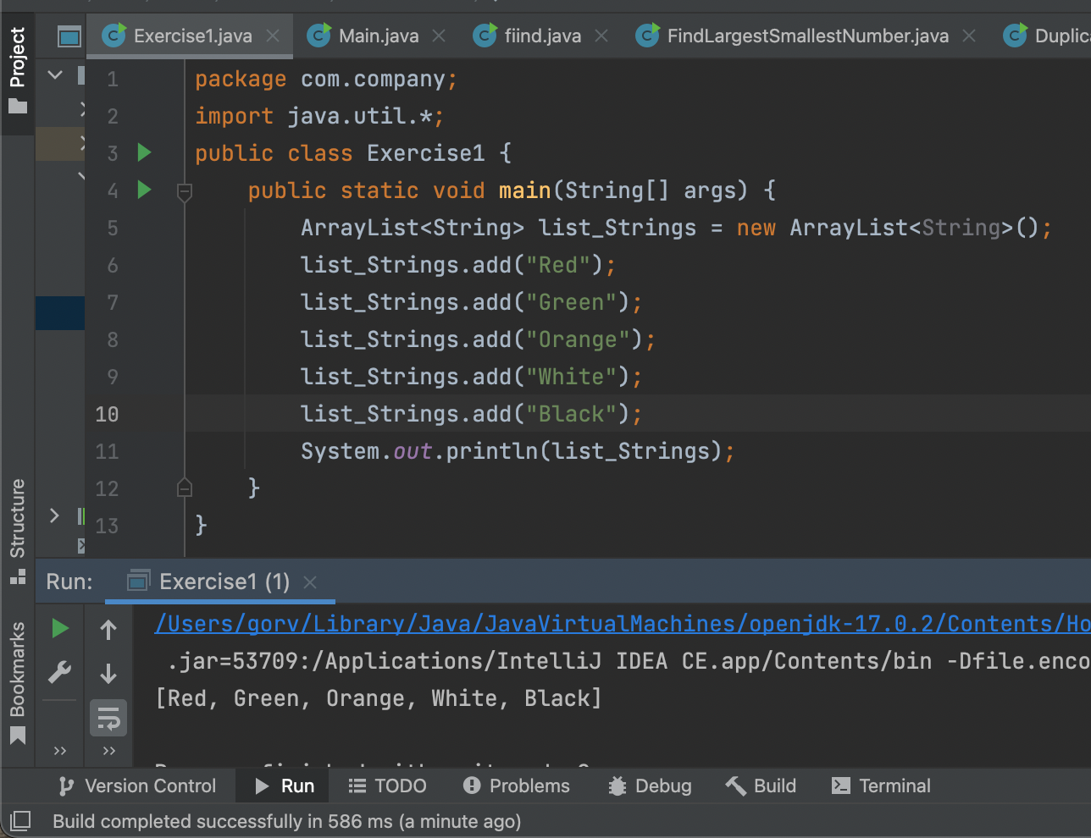

**Q2 Write a Java program to append the specified element to the end of a hash set.**

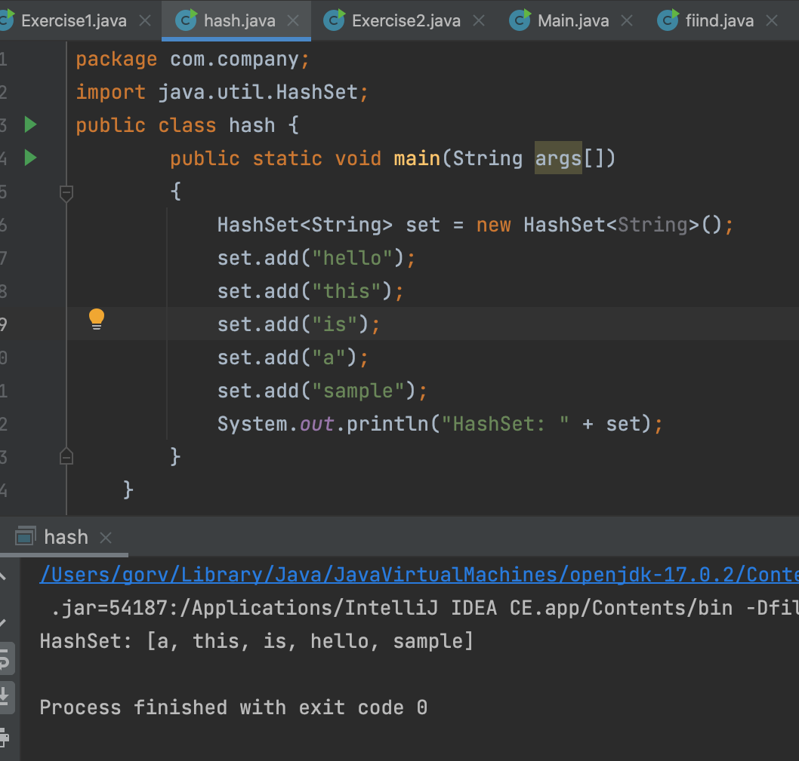

**Q3 Write a Java program to iterate through all elements in a hash list.**

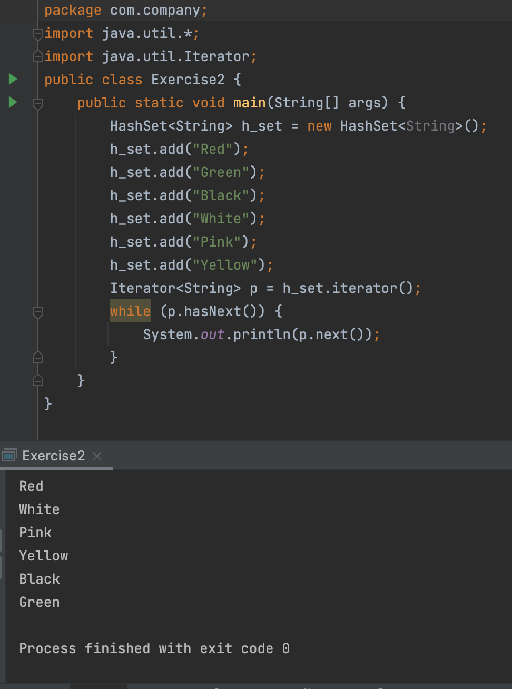

**Q4 Write a Java program to get the number of elements in a hash set.**

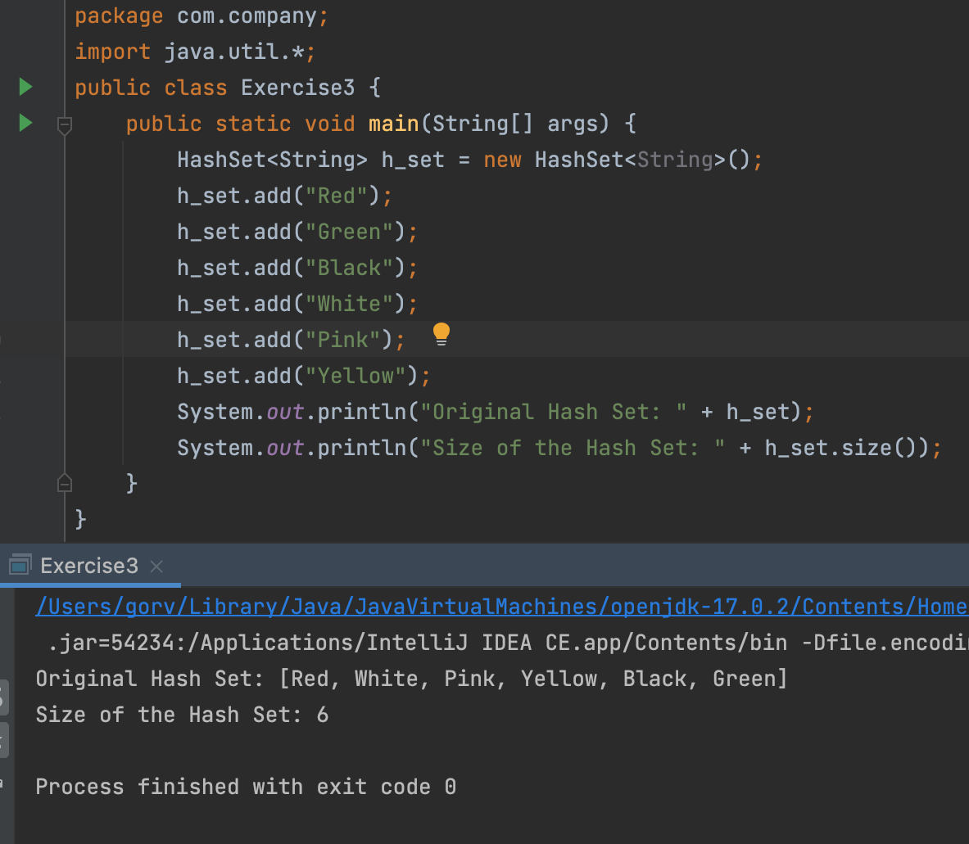

**5. Learning outcomes (What I have learnt):**

**1. Implementation of ArrayList**

**2. Implementation of HashSet**

**3. methos in Arraylist & HashSet**

**6. Evaluation Grid:**

|  |  |  |  |
| --- | --- | --- | --- |
| Sr. No. | Parameters | Marks Obtained | Maximum Marks |
| 1. | Worksheet |  | 10 |
| 2. | Demonstration/Performance /Pre Lab Quiz |  | 5 |
| 3. | Post Lab Quiz |  | 5 |